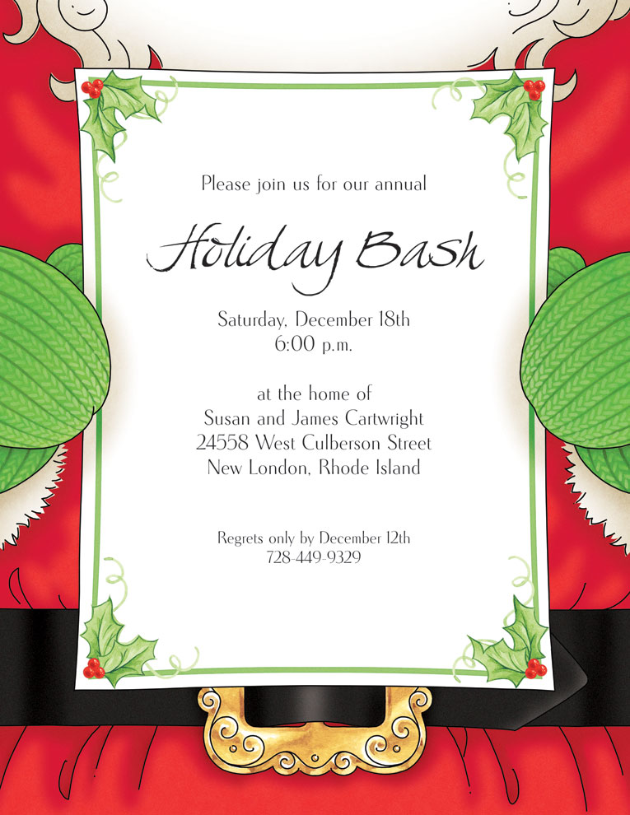

*Insert Santa’s response here for Kindergarten*



*Insert Santa’s response here for Grade 2*

Insert Santa’s text here

