Indigenous/First Nations
FICTION/SHORT STORIES/POETRY

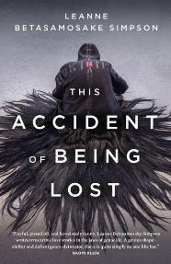
F SIM
Simpson, Leanne Betasamosake
This accident of being lost : songs and stories
This Accident of Being Lost is the knife-sharp new collection of stories and songs from award-winning Nishnaabeg storyteller and writer Leanne Betasamosake Simpson. These visionary pieces build upon Simpson's powerful use of the fragment as a tool for intervention in her critically acclaimed collection Islands of Decolonial Love. Provocateur and poet, she continually rebirths a decolonized reality, one that circles in and out of time and resists dominant narratives or comfortable categorization.
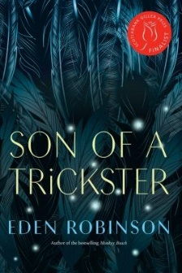
F ROB
Robinson, Eden
Son of a trickster
Everyone knows a guy like Jared: the sixteen-year-old burnout in high school who sells weed cookies and has a scary mom who's often wasted and wielding some kind of weapon. Jared smokes and drinks too much, and his mom is a mess, and he can't rely on anyone for consistent love and support, except for his flatulent pit bull, Baby Killer, but now she's dead. He's also a kid with an immense capacaity for compassion and an impulse to watch over people more than twice his age, and he tries his best to stabilize his family and keep everything afloat. But it's weird the way he sometimes blacks out. And he puzzles over why his maternal grandmother has never liked him, why she says he's the son of a trickster, that he isn't human. Also, ravens have begun to speak to him-even when he's not stoned. You think you know Jared, but you don't.
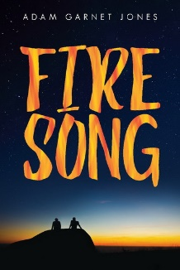
F JON
Jones, Adam Garnet
Fire song
Shane is still reeling from the suicide of his kid sister, Destiny. How could he have missed the fact that she was so sad? He tries to share his grief with his girlfriend, Tara, but she’s too concerned with her own needs to offer him much comfort. What he really wants is to be able to turn to the one person on the rez whom he loves—his friend, David.
Things go from bad to worse as Shane’s dream of going to university is shattered and his grieving mother withdraws from the world. Worst of all, he and David have to hide their relationship from everyone. Shane feels that his only chance of a better life is moving to Toronto, but David refuses to join him. When yet another tragedy strikes, the two boys have to make difficult choices about their future together.
With deep insight into the life of Indigenous people on the reserve, this book masterfully portrays how a community looks to the past for guidance and comfort while fearing a future of poverty and shame. Shane’s rocky road to finding himself takes many twists and turns, but ultimately ends with him on a path that doesn’t always offer easy answers, but one that leaves the reader optimistic about his fate.
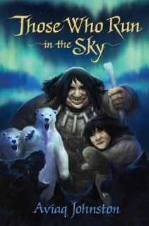
F JOH
Johnston, Aviaq
Those who run in the sky
After a strange and violent blizzard leaves young shaman-in-training Pitu stranded on the sea ice--without his dog team or any weapons to defend himself--he soon realizes that he is no longer in the word that he once knew. The storm has carried him into the world of the spirits, a world populated by terrifying creatures. As he tries to find his way back home, Pitu is plagued by black wolves with red eyes, ravenous and constantly stalking him, water-dwelling creatures that want nothing more than to snatch him and pull him into the frigid ocean through an ice crack, as well as beings less frightening, but equally as incredible, such as a lone giant who can carry Pitu in the palm of her hand and keeps caribou and polar bears as pets. After stumbling upon a fellow shaman who has been trapped in the spirit world for many years, Pitu must master all of his shamanic powers to make his way back to the world of the living, to his family and to the girl that he loves.
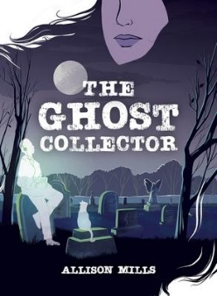
F MIL
Mills, Allison
The ghost collector
Shelly and her grandmother catch ghosts. In their hair.
Just like all the women in their family, they can see souls who haven’t transitioned yet; it’s their job to help the ghosts along their journey. When Shelly’s mom dies suddenly, Shelly’s relationship to ghosts—and death—changes. Instead of helping spirits move on, Shelly starts hoarding them. But no matter how many ghost cats, dogs, or people she hides in her room, Shelly can’t ignore the one ghost that’s missing. Why hasn’t her mom’s ghost come home yet?
Rooted in a Cree worldview and inspired by stories about the author’s great-grandmother’s life, The Ghost Collector delves into questions of grief and loss, and introduces an exciting new voice in tween fiction that will appeal to fans of Kate DiCamillo’s Louisiana’s Way Home and Patrick Ness’s A Monster Calls.

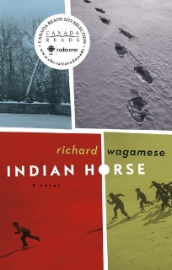
F WAG
Wagamese, Richard
Indian horse : a novel
Saul Indian Horse is dying. Tucked away in a hospice high above the clash and clang of a big city, he embarks on a marvellous journey of imagination back through the life he led as a northern Ojibway, with all its sorrows and joys.
With compassion and insight, author Richard Wagamese traces through his fictional characters the decline of a culture and a cultural way. For Saul, taken forcibly from the land and his family when he's sent to residential school, salvation comes for a while through his incredible gifts as a hockey player. But in the harsh realities of 1960s Canada, he battles obdurate racism and the spirit-destroying effects of cultural alienation and displacement.
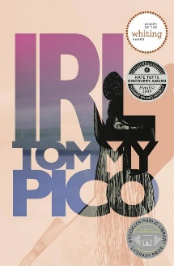
811.6 PIC
Pico, Tommy
IRL
IRL is a sweaty, summertime poem composed like a long text message. It follows Teebs, a reservation-born, queer NDN weirdo, trying to figure out his impulses/desires/history in the midst of Brooklyn rooftops, privacy in the age of the Internet, street harassment, suicide, boys boys boys, literature, colonialism, religion, leaving one's 20s, and a love/hate relationship with English. He's plagued by an indecision, unsure of which obsessions, attractions, and impulses are essentially his, and which are the result of Christian conversion, hetero- patriarchal/colonialist white supremacy, homophobia, Bacardi, gummy candy, and not getting laid. IRL asks, what happens to a modern, queer indigenous person a few generations after his ancestors were alienated from their language, their religion, and their history?
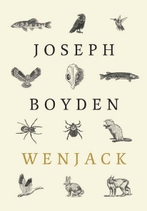
F BOY
Boyden, Joseph
Wenjack
An Ojibwe boy runs away from a North Ontario Indian School. He realizes too late just how far away home is. Along the way hes̉ followed by Manitous, spirits of the forest who comment on his plight, cajoling, taunting, and ultimately offering him a type of comfort on his difficult journey back to the place he was so brutally removed from.

Graphic Novels

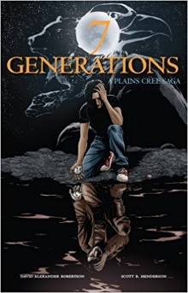
GRA ROB
Robertson, David Alexander
7 generations : a Plains Cree saga
Follows one Plains Cree family from the early 19th century to the present day. For Edwin, the story of his ancestors from both the distant and recent past must guide him through an uncertain present, to the dawn of a new future. 7 Generations explores the life of Stone, a young Cree warrior, the smallpox epidemic of 1870, the residential school system of the 20th century and its familial legacy.

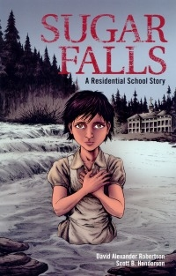
GRA ROB
Robertson, David Alexander
Sugar Falls : a residential school story
A school assignment to interview a residential school survivor leaders Daniel to Betsy, his friend's grandmother, who tells him her story. Abandoned as a young child, Betsy was soon adopted into a loving family. A few short years later, at the age of 8, everything changed. Betsy was taken away to a residential school. There she was forced to endure abuse and indignity, but she remembers her fathers words - words that gave her the resilience, strength, and determination to survive.

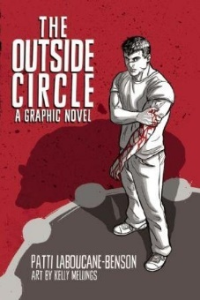
GRA LAB
LaBoucane-Benson, Patti
The outside circle
In this important graphic novel, two Aboriginal brothers surrounded by poverty, drug abuse, and gang violence, try to overcome centuries of historic trauma in very different ways to bring about positive change in their lives.
Pete, a young Aboriginal man wrapped up in gang violence, lives with his younger brother, Joey, and his mother who is a heroin addict. One night, Pete and his mother’s boyfriend, Dennis, get into a big fight, which sends Dennis to the morgue and Pete to jail. Initially, Pete keeps up ties to his crew, until a jail brawl forces him to realize the negative influence he has become on Joey, which encourages him to begin a process of rehabilitation that includes traditional Aboriginal healing circles and ceremonies.
Powerful, courageous, and deeply moving, The Outside Circle is drawn from the author’s twenty years of work and research on healing and reconciliation of gang-affiliated or incarcerated Aboriginal men.
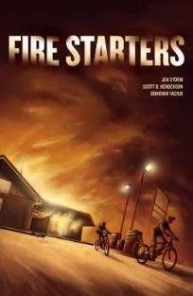
GRA STO
Storm, Jennifer
Fire starters
Looking for a little mischief after finding an old flare gun, Ron and Ben suddenly find themselves in trouble when the local gas bar on Agamiing Reserve goes up in flames, and they are wrongly accused of arson by the sheriff's son. As the investigation goes forward, community attitudes are revealed, and the truth slowly comes to light.

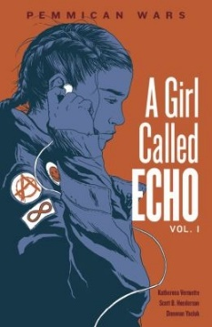
GRA VER
Vermette, Katherena
A girl called Echo, 01: Pemmican Wars
Echo Desjardins, a 13 year-old Métis girl, is struggling with her feelings of loneliness while attending a new school and living with a new foster family. Then an ordinary day in Mr. Bee's history class turns extraordinary and Echo's life will never be the same. During Mr. Bee's lecture, Echo finds herself transported to another time and place--a bison hunt on the Saskatchewan prairie--and back again to the present. In the following weeks, Echo slips back and forth in time. She visits a Métis camp, travels the old fur trade routes, and experiences the perilous and bygone era of the Pemmican Wars.
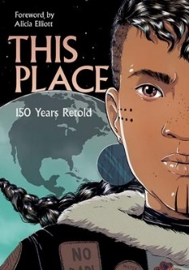
GRA ELL
Elliott, Alicia
This place: 150 years retold
Explore the past 150 years in what is now Canada through the eyes of Indigenous creators in this groundbreaking graphic novel anthology. Beautifully illustrated, these stories are an emotional and enlightening journey through indigenous wonderworks, psychic battles, and time travel. See how Indigenous peoples have survived a post-apocalyptic world since Contact.

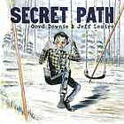
GRA DOW
Downie, Gord
Secret path
The story of Chanie Wenjack (misnamed Charlie by his teachers), a twelve-year-old boy who died in flight from the Cecilia Jeffrey Indian Residential School fifty years ago.

Non-Fiction

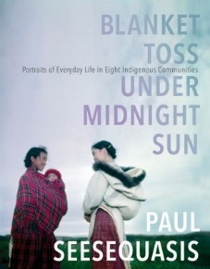
971 SEE
Seesequasis, Paul
Blanket toss under midnight sun : portraits of everyday life in eight Indigenous communities
In 2015, writer and journalist Paul Seesequasis found himself grappling with the devastating findings of Canada's Truth and Reconciliation Commission report on the residential school system. He sought understanding and inspiration in the stories of his mother, herself a residential school survivor. Gradually, Paul realized that another, mostly untold history existed alongside the official one: that of how Indigenous peoples and communities had held together during even the most difficult times. He embarked on a social media project to collect archival photos capturing everyday life in First Nations, Metis and Inuit communities from the 1920s through the 1970s. As he scoured archives and libraries, Paul uncovered a trove of candid images and began to post these on social media, where they sparked an extraordinary reaction. Friends and relatives of the individuals in the photographs commented online, and through this dialogue, rich histories came to light for the first time.
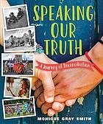
371.82 GRA
Gray Smith, Monique
Speaking our truth : a journey of reconciliation
This nonfiction book examines how we can foster reconciliation with Indigenous people at individual, family, community and national levels.

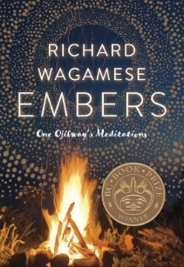
299.7 WAG
Wagamese, Richard
Embers : one Ojibway's meditations
In this carefully curated selection of everyday reflections, Richard Wagamese finds lessons in both the mundane and sublime as he muses on the universe, drawing inspiration from working in the bush--sawing and cutting and stacking wood for winter as well as the smudge ceremony to bring him closer to the Creator. Embers is perhaps Richard Wagamese's most personal volume to date. Honest, evocative and articulate, he explores the various manifestations of grief, joy, recovery, beauty, gratitude, physicality and spirituality--concepts many find hard to express. But for Wagamese, spirituality is multifaceted. Within these pages, readers will find hard-won and concrete wisdom on how to feel the joy in the everyday things. Wagamese does not seek to be a teacher or guru, but these observations made along his own journey to become, as he says, "a spiritual bad-ass, " make inspiring reading.

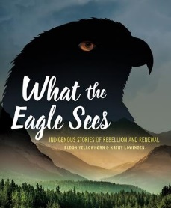
970 YEL
Yellowhorn, Eldon
What the eagle sees: Indigenous stories of rebellion and...
What do people do when their civilization is invaded? Indigenous people have been faced with disease, war, broken promises, and forced assimilation. Despite crushing losses and insurmountable challenges, they formed new nations from the remnants of old ones, they adopted new ideas and built on them, they fought back, and they kept their cultures alive. When the only possible “victory” was survival, they survived.

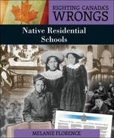
371.82 FLO
Florance, Melanie
Righting canadas wrongs : residential schools
Canada's residential school system for aboriginal young people is now recognized as a grievous historic wrong committed against First Nations, Metis, and Inuit peoples. This book documents this subject in a format that will give all young people access to this painful part of Canadian history.

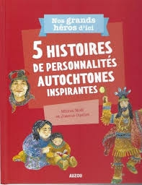
971.2 NOE
Noël, Michel
5 histoires de personnalités autochtones inspirantes
Découvrez des personnalités autochtones qui ont changé le cours des choses. Faites connaissance avec Membertou, Kateri Tekakwitha, Louis Riel, Joséphine Bacon et Taamusi Qumaq. Chaque livre de la collection comprend la présentation de cinq hommes ou femmes d'exception qui ont accompli des exploits qui resteront gravés dans nos mémoires à jamais.

